**Report for Assignment 3**

**The visualization of the urban forest in Milan**

**Introduction**

In this phase, Our group analyses tree data and geographic information in an urban forest in one part of Milan. The tree data was visualized through geographical modeling of the areas involved and by abstracting multiple trees from the plot site into a single tree. We hope to create the physical model of the spatial site relationship between the urban forest and the surrounding area in the data, and the trees model for every plot to give the inhabitants a better understanding of their permanent surroundings.

**Data overview and targets**

The topic of our data is the urban forest. We obtained information about the trees planted a place in Milan, Italy, and a report on their data from our data holder. They include the location (latitude and longitude) of the 25 sampled sites (called plot) in the region, which is chosen by the data holder, and information on tree species and growth statistics for each site. We have used this data to complete the previous analysis of Assignment 2.

In Assignment 2, we found information on tree height, diameter at breast height, which represents the situation of tree growth. At the same time, we found that the multiple datasets given were strung together from the plots, which are the different sampling locations selected by the data holder. We hope that the location data will allow the urban forest in this area to be located in the city and, together with the information on the trees in the plot, allow the people living in the surrounding area to become more aware of the urban forest and the natural environment around them. This phase aims to present the urban forest and the surrounding spatial-site relationship, as well as the growth of the trees in the forest, in an appropriate way to the residents of the area.

**Visualization design**

We wanted to enhance the visualization of the geographic information and the condition of the trees within it with an intuitively visible physical object, in a palpable form, rather than a virtual flat image, while enhancing the display of the spatial site relationships between the forest and its surroundings. However, as we further processed the data we had, we found that we only had the latitude and longitude for each plot. They are only allowed us to represent the location of each point on a flat map, whereas to show the site relationships, we needed the appropriate topographic/elevation data for the area to show its spatial state and location.

Therefore, we chose to use the latitude and longitude information provided and the topographical information we could find for the location to create a physical contour plot model and add tree models at each plot location to show the spatial site relationship and tree growth of Urban Forest and the surrounding area.

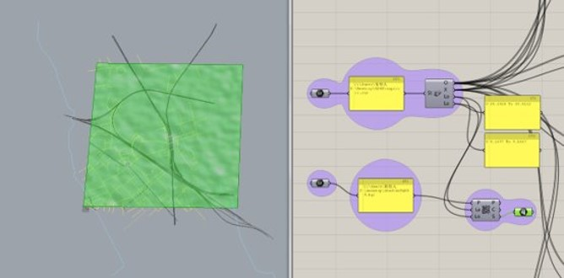

Figure 1: The process of modeling in grasshopper about terrain

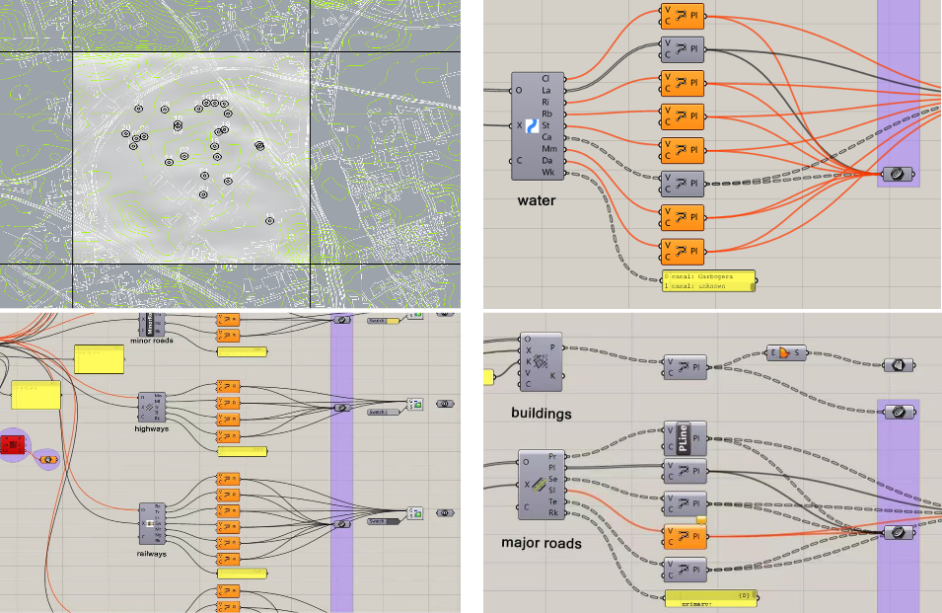

Figure 2: Modeling process in grasshopper about city details

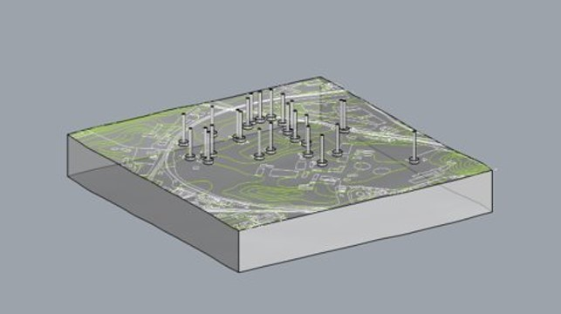

Figure 3: The Model of the area with contour data

桌子上的电脑绘图

Figure 4(left) and 5(right): Laser cutting and model making

There is no specific location information for each tree in the tree data set for each plot. We can only represent all the tree information in a plot at a single location point. In contrast, we want to represent both tree species, the number of trees of each species, their height and thickness status in a single plot. So, we abstract all the trees in a plot as one tree, using different colors to represent different species, different height forks to represent the average height of different species. Moreover, we also use different colored leaf cluster sizes(number of leaves) to represent the number of different species in the plot. The diameter at breast height, which indicates the thickness of the tree, is represented by concentric bases of different diameters.

日程表

Figure 6: the design of the abstract tree for every plot

Once again, we have subdivided the data. The tree information was classified according to the different plots, the data we needed was counted, and the different tree species were matched with different colors as a reference for our solid model making.

To give the impact of urban forest on people living around it, we wondered whether we could also include its impact on the environment or air as part of our observations to the residents. After reading the corresponding data reports provided by the data holder, we found a section with statistics on the carbon absorption capacity of the trees. This section can be used as the 'real impact' that we can show to the residents, that is, the 'reduction' of carbon by the trees. As air is not a visible form and can only be replaced by other means, we chose to use the intensity of the light to show how well different tree species absorb carbon dioxide. As trees reduce carbon dioxide by photosynthesis in the same way that people breathe, we chose to use the light effect of breathing to show carbon dioxide absorption.

Figure 7: The light of the top sixth carbon absorption capacities in all species of trees

**Outcome and findings:**

Our actual model is as shown below, and also in our video.

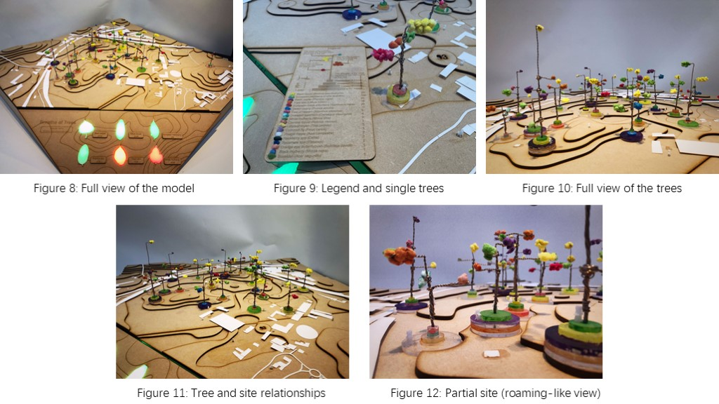

Once the physical model was completed, the following observations were made in the model that represented the actual spatial site relationships:

Firstly, the surveyed plots were concentrated in the northeast and north of the site, with the southwest being largely unsampled. Secondly, Black Locus and European Hackberry were present and growing well in most plots. They were generally taller and had larger diameters at breast height (thicker trees) than other trees in the same plot.

Thirdly, on our solid tree model, we can see that the purple circle is bigger than all the other circles, which means that the black poplar always has a thicker trunk than the other trees. Fourthly, our solid tree model concludes that taller trees have thicker trunks (larger diameter at breast height). This pattern can be verified in the model of plot 18.

Finally, combining the survey report given to us by the data holder with our validation calculations, we found that not all trees in the area contribute to carbon sequestration. Only four species of trees can contribute positively to local carbon uptake, and the rest are even releasing carbon into the environment (which we have indicated by red lights on the light effect).